CMSC 335 – Object-Oriented Programming and Data Structures

Project 3: Java Swing Traffic Simulation

Submitted by:
Ricardo Beckford

Instructor:
Douglas Mujeye

Course:
CMSC 335 – University of Maryland Global Campus

Date:
December 09, 2025

UML diagram
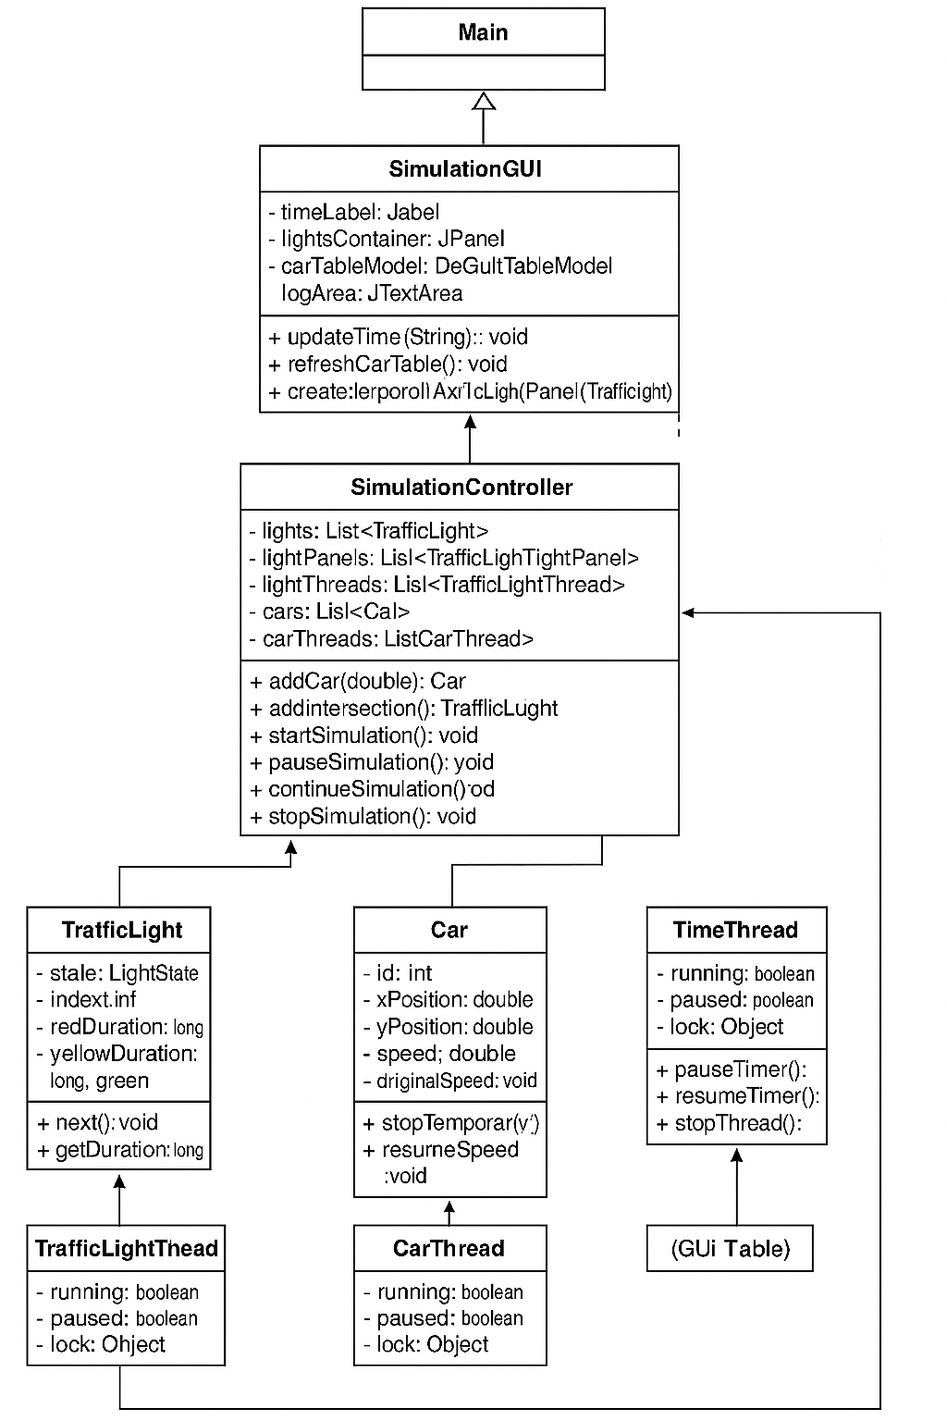

TEST PLAN TABLE
Test # | Test Description | Steps Performed | Expected Result | Actual Result | Pass/Fail
1 | Application launches | Run Main.java | GUI window opens with time panel, lights panel, car table, buttons, and log area | Expected result | Pass
2 | Time updates every second | Start simulation and observe time for 5–7 seconds | Time increments at 1-second intervals | Expected result | Pass
3 | Traffic lights cycle | Observe a light for 12 seconds | Light changes: RED → GREEN → YELLOW → repeat | Expected result | Pass
4 | Add Car | Click Add Car → enter speed | Car appears in table and X position increases | Expected result | Pass
5 | Add Intersection | Click Add Intersection | New traffic light appears and cycles like others | Expected result | Pass
6 | Pause freezes threads | Start → Add Car → Pause → observe | Time stops, car X stops, lights stop | Expected result | Pass
7 | Continue resumes threads | After Pause, click Continue | Time resumes, car moves, lights resume cycling | Expected result | Pass
8 | Stop ends simulation | Click Stop | All threads stop; nothing updates | Expected result | Pass
9 | Add multiple cars | Add 3 cars quickly | All cars appear and update independently | Expected result | Pass
10 | Car stops at RED light | Add a slow car → wait until intersection is red | Car stops within ~5 meters of intersection when light is RED | Expected result | Pass

Screenshot of Test case:
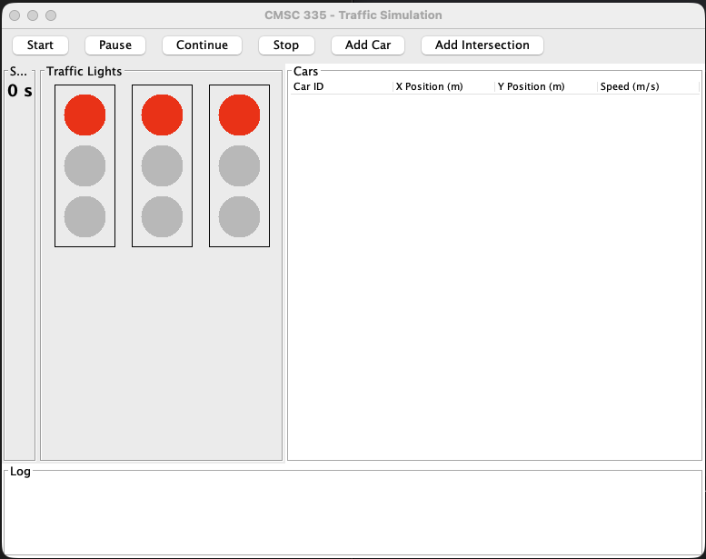
Figure 1. Main Screen Display of the Traffic Simulation Application
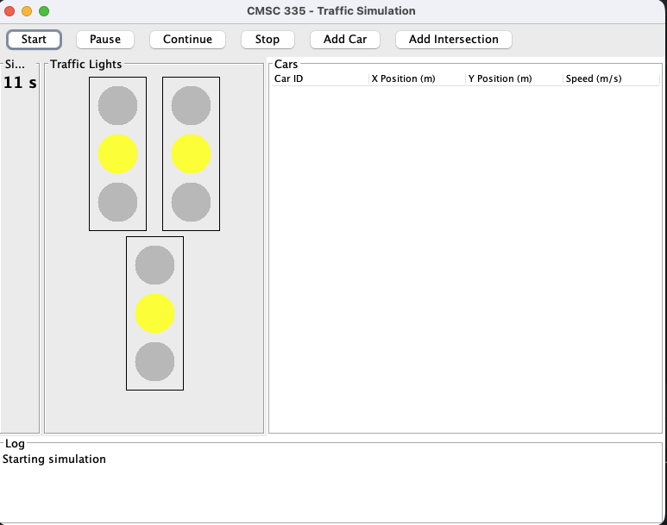
Figure 2. Initialization of the Three Default Traffic Light Intersections

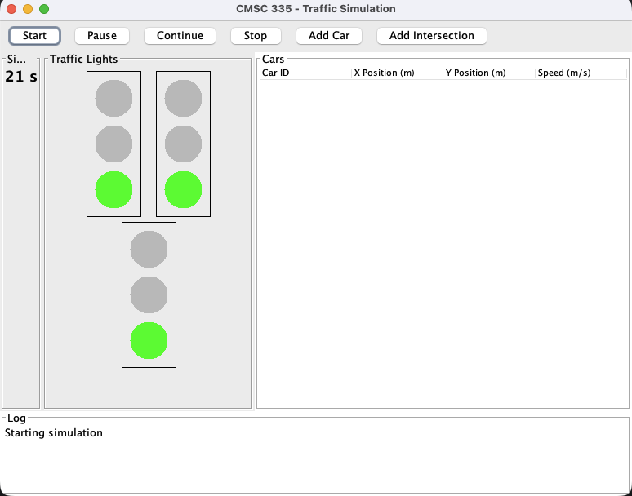
Figure 3. Real-Time Traffic Light State Change During the Simulation
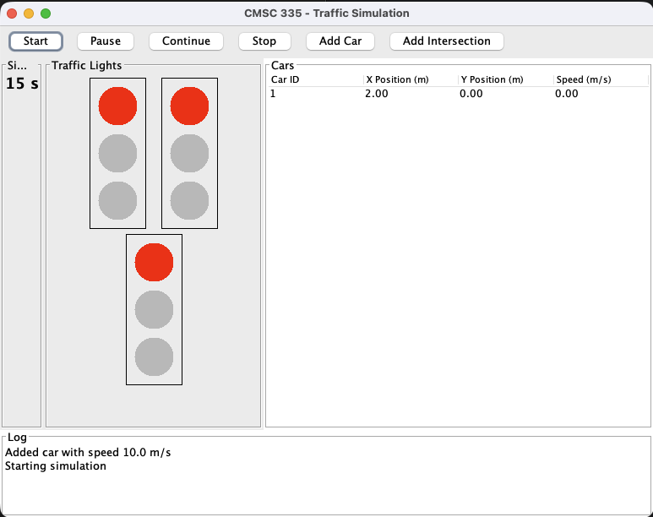
Figure 4. Car Table Display Showing Real-Time Car Position and Speed Updates

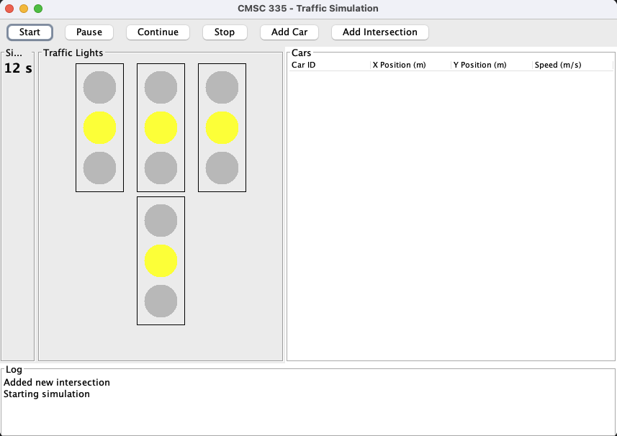
Figure 5. Adding a New Car Through the User Input Prompt
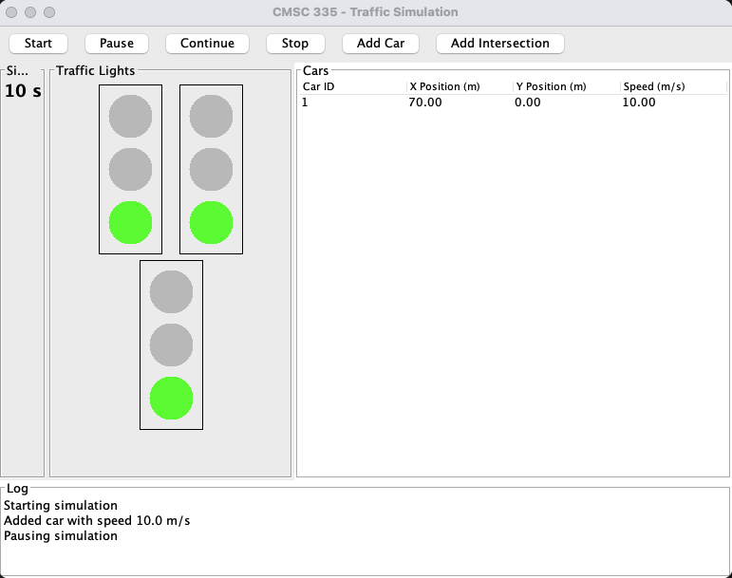
Figure 6. Vehicle Movement at Runtime Across Multiple Intersections

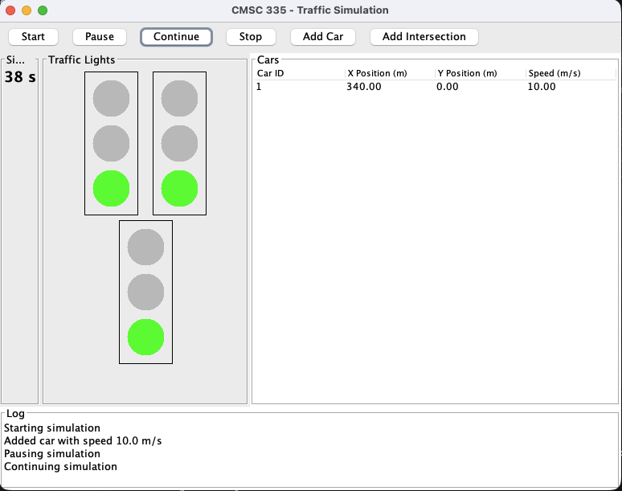
Figure 7. Car Stopping at a Red Light Based on the Intersection Logic
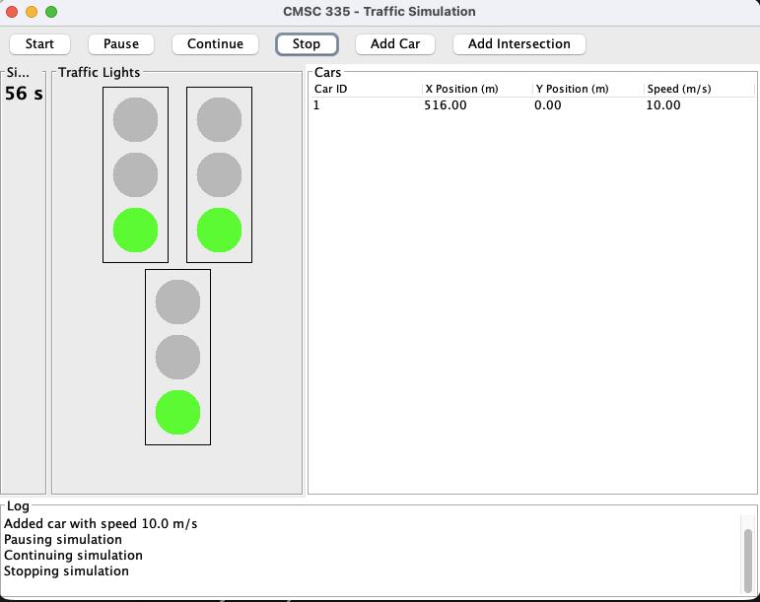
Figure 8. Simulation Paused with All Threads Temporarily Halted
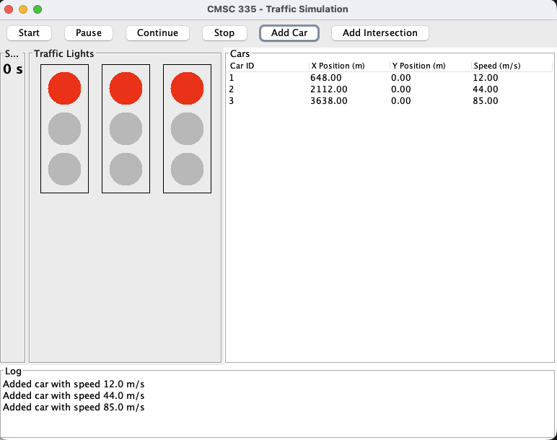
Figure 9. Simulation Continued After Pause, Resuming All Thread Activity
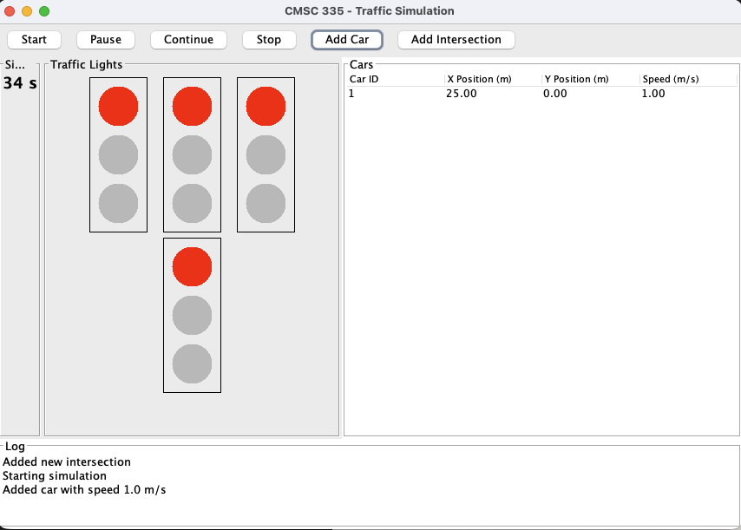
Figure 10. Adding an Additional Intersection During Active Simulation

Lessons Learned:
This project helped me understand how threads actually behave when everything runs simultaneously. I saw how each part of the simulation needs its own space to work but still has to stay in sync with the rest of the system. I learned how important it is to control thread flow correctly, especially when pausing and resuming the simulation. If one thread does not pause correctly, the whole screen feels out of sync.

I also learned how much Swing depends on sending updates to the right place. Any visual change has to go through the Event Dispatch Thread, so I had to use SwingUtilities.invokeLater correctly. Building the GUI taught me how layout choices affect clarity, and how keeping the code organized between the model, controller, threads, and panels makes testing simpler. Overall, this project helped me become more confident with Java concurrency, GUI design, UML-based planning, and breaking a large idea into smaller, manageable parts.

Assumptions and Limitations:

For this simulation, I made several assumptions to ensure that the design remains clear and manageable. I assumed that cars only travel in a straight line and that their Y position never changes. Intersections are consistently spaced, and each traffic light operates on a simple cycle with a repeating timing pattern. Cars maintain a steady speed until they encounter a red light, at which point they stop until the signal permits them to proceed. The timing is based on the thread's sleep method, which may introduce slight delays depending on system load.

There are also a few limitations in this project. Cars do not interact with one another, and there are no turning maneuvers or detailed driving behaviors. The simulation does not use real physics; it only updates speed and distance. The traffic light panels change colors simply, without any animation, and performance may degrade as more cars or intersections are added. Additionally, nothing is saved when the program closes, so each run starts fresh.

These choices were made to keep the focus on learning concurrency, event handling, and building a straightforward Java Swing interface.

Conclusion:

This project brought together all the major skills from the course and showed how they work in one full application. I was able to design a simple but complete traffic simulation that uses threads, shared objects, and a Java Swing interface. Building separate threads for cars, traffic lights, and the timer helped me see how timing and flow control affect the whole system. Creating the GUI showed me how much planning is needed to keep the layout clear and responsive. The process also helped me understand the value of UML diagrams and test plans, because they made the code easier to organize and verify. Overall, the project strengthened my understanding of concurrency, event handling, and object-oriented design, and it gave me confidence to build larger and more interactive programs in the future.

